How to Earn Bonus Coins Visual Support
Instructions for Use
I created this visual support (on the next page of this document) for a middle school student in an inclusion classroom. He was currently using a token economy system in which I would place a plastic gold coin in a jar on his desk when I saw him on-task (either working on his assignment or looking at the teacher if he or she was speaking). Since the student typically did not focus in this class for a sustained period of time, I was giving him a coin probably about every 30 seconds if he was on task. As he successfully was able to remain on-task for longer periods of time, I would give him a coin at gradually increasing intervals of time. When the jar was filled up to a line written on the jar, the student received a 5 minute break to engage in a quiet activity of his choice.
The bonus coin visual support was used to reward the student for other appropriate behaviors that I hoped to teach. The student currently would not regularly
(1) return a teacher or peer’s greeting (such as “Hi” or “Good morning”),
(2) get his notebook for class,
(3) push in his chair at the end of class, and
(4) putting away his notebook at the end of class
without being reminded to do so. The student had been taught these skills in the past, but appeared to lack to motivation for engaging in the behaviors. So, I wanted to implement a system to reward him for engaging in these behaviors. The “How to Earn Bonus Coins” visual support was placed on the student’s desk as a reminder to complete the behaviors and that he would receive a bonus coin for doing so.
At first, I needed to directly remind (through verbal instructions and modeling) the student to engage in the behaviors. When the student would complete one of the behaviors on the chart, I would verbally praise him (“Thank you for saying good morning to me!”) and place a “bonus coin” in his jar. After several weeks of practice, the student would return my morning greetings with no prompting, but I continue to give him the bonus coins. Once this becomes more of a habit, I can begin to fade out giving the bonus coins to a more intermittent schedule.
With the behaviors such as putting away his notebook and pushing in his chair, I eventually only needed to say to him, “What do you need to do at the end of class?” and point to the visual support page on his desk. Eventually, I no longer needed that indirect prompt, and I give him bonus coins in his jar (that stay there for the next class period) when he independently pushes in the chair and puts away his notebook.

How to Earn Bonus Coins

When someone tells you “Hi” or “Good Morning,” look at them and respond.

Answer a teacher’s question the first time he or she asks.

Get your notebook as soon as you walk in the room.
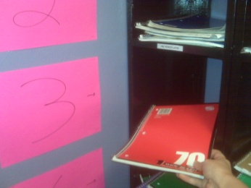

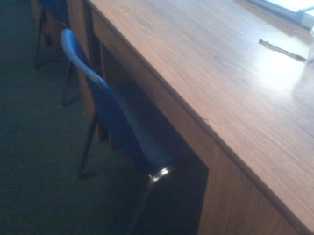

Push in your chair after class.

Put away your notebook after class.

